To find all the linearly separable (l.s.) 3-dimensional Boolean functions we consider each case with different number of active neurons and find how many linearly separable functions each case has by visualizing a cube with different corners active that has to be separated by a plane and how many different ways this is possible. In the figures below the red is the plane separating the active functions symbolized by the green points.

1. 1 way to separate 0 active points.
2. 8 ways to separate 1 active points only one symmetry (each corner) which is linearly separable that has 8 different combinations.
3. 12 ways only 1 symmetry that is l.s. which is when the active corners are next to each other. This leads to all the edges being a combination for this symmetry.
4. 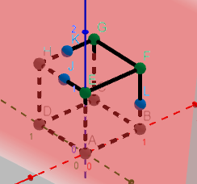24 ways only 1 symmetry that is l.s which is when the active corners are only 1 step in any direction (x,y,z) meaning they are all linked similarly to (2.) but with 3 active instead of 2. This leads to 4 combinations of this symmetry on each face therefore 4\*6=24 ways.
5. 12 ways only 2 symmetries that is l.s.which are when all the corners on a face is active giving 8 combinations and one that is less trivial but when a corner is active and all its neighbours giving a combination for each corner 6. Giving the total amount of combinations for these 2 symmetries 8+6=12.  
   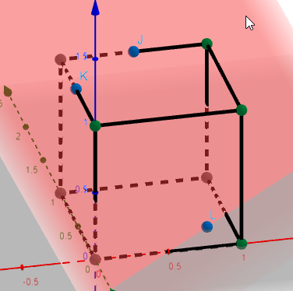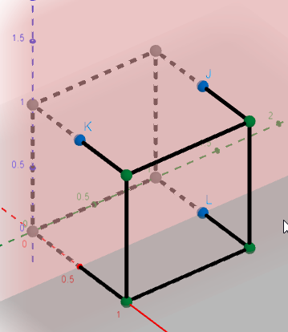
6. 24 same as 3.) due to the fact that there is always a total of 8 possible points and if the plane doesn’t cut through any of the points then the sum of the points on one side and the other side of the plain must always equal 8. By this reasoning which side of the plane the points can be chosen and if all l.s. combinations was found for 3 points then this must equal the same amount of combinations for 5 points active (8-3=5). This argument is valid for 6,7 and 8 active points.
7. 12
8. 8
9. 1

Leading to a total of 2\*(1+8+12+24)+(6+8)=104 l.s. 3-dimensional Boolean functions.